# ME210 Team Meetings

# 02/19/2018:

Set the agenda for :

* Play game
* Four ideas
* Presentation
* Scheduling
* Inventory

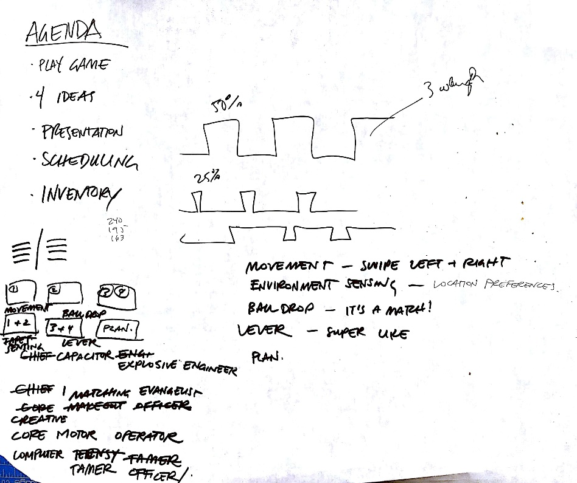

Played the game with human robots to figure out the details of the rules and figure out some of the best strategy. Questions left to answer: can we leave pieces of the robot on the field? What does the push button looks like? Figured out that moving side ways (crab walk) was more efficient time wise.

Presented the different ideas for the robot. Lever adopted, questioning about the torque needed.

Brainstormed on the ball delivery mechanism: wheel and hole or solenoid gate?

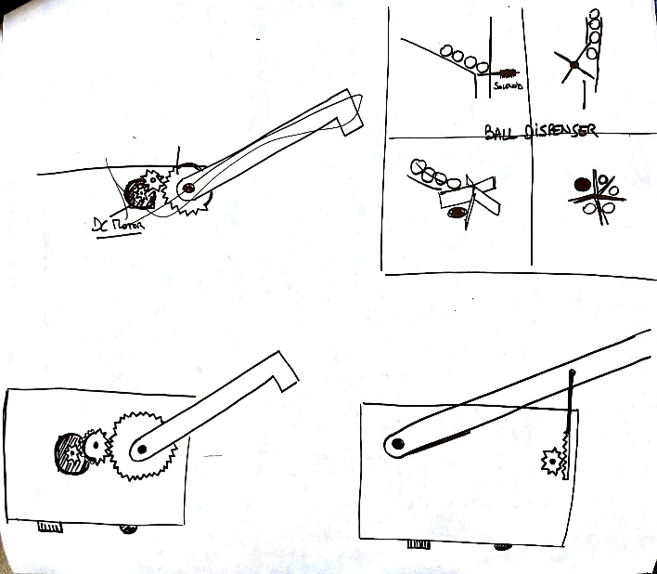

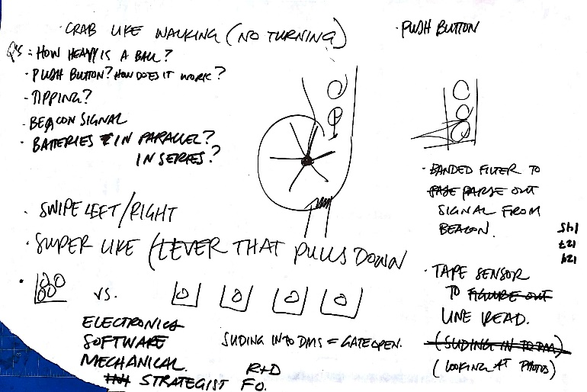

Talked a little about the wheel disposition plus caster

s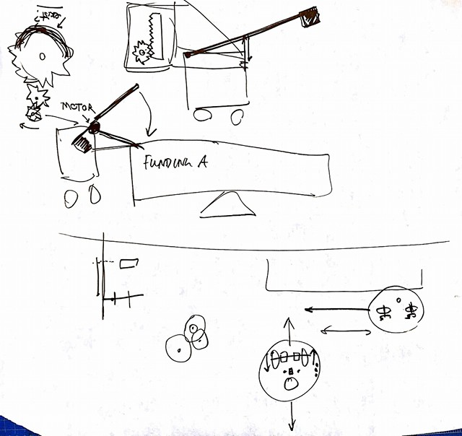

Sorted out the task, material, sub-task chart

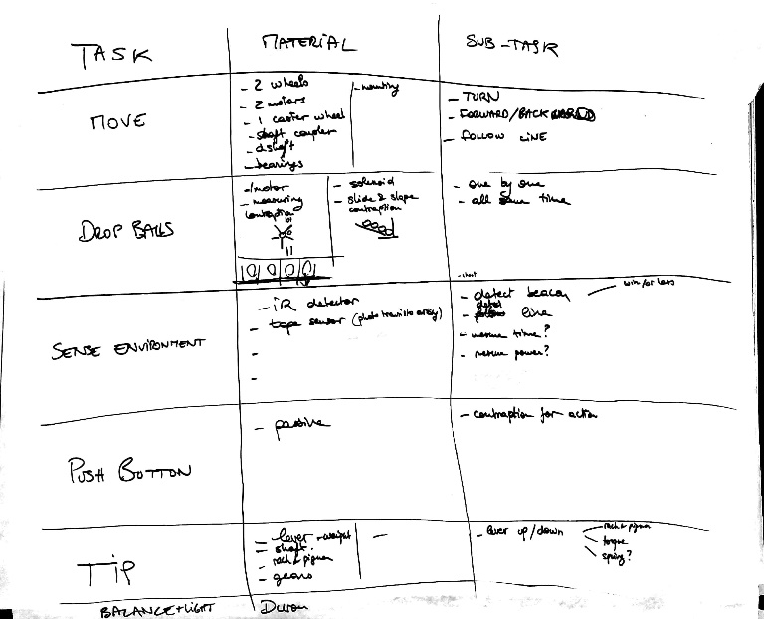

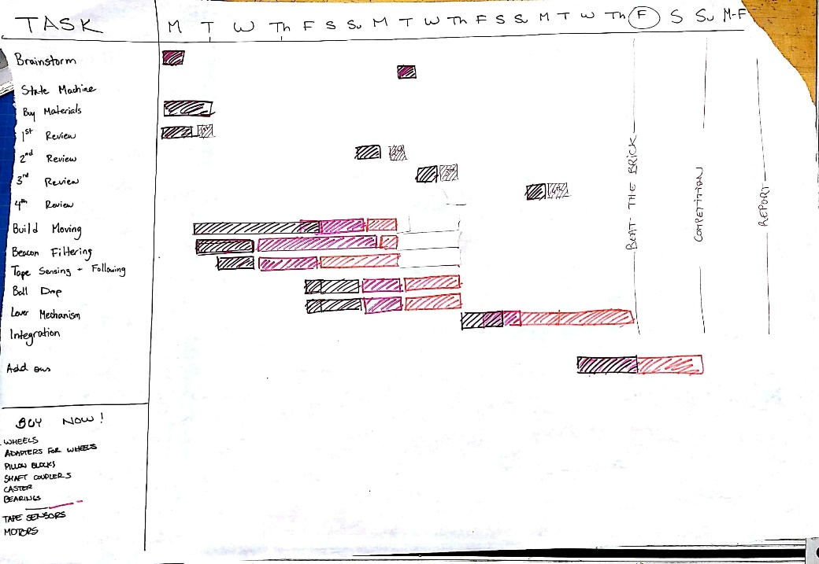

Worked on the Gantt chart

Worked on the buy list (see material)

[https://docs.google.com/spreadsheets/d/1QndJx4MC7VWpCDq9B-suB-2LvONYPwA5EuEKMvLyQ7s/edit#gid=0](https://l.facebook.com/l.php?u=https%3A%2F%2Fdocs.google.com%2Fspreadsheets%2Fd%2F1QndJx4MC7VWpCDq9B-suB-2LvONYPwA5EuEKMvLyQ7s%2Fedit%23gid%3D0&h=ATPm6RP0Q2J2p8QPsKigPzXKXr2Wrhg922K7Dn7pGWldaHGBiNrIhAi0Jjsu6mEGsi0Iq21_a2qRZbE54qRp6xiPuOzk0weScg2GJTAmXJKTc3cb9OI)

Prepared the slides:

[https://docs.google.com/presentation/d/1fEGLEI6NK_dW6Pb4yWJn_U2qOSrptY-A2cQ5sOQAW5k/edit?pli=1#slide=id.g3606f1c2d_30](https://l.facebook.com/l.php?u=https%3A%2F%2Fdocs.google.com%2Fpresentation%2Fd%2F1fEGLEI6NK_dW6Pb4yWJn_U2qOSrptY-A2cQ5sOQAW5k%2Fedit%3Fpli%3D1%23slide%3Did.g3606f1c2d_30&h=ATPm6RP0Q2J2p8QPsKigPzXKXr2Wrhg922K7Dn7pGWldaHGBiNrIhAi0Jjsu6mEGsi0Iq21_a2qRZbE54qRp6xiPuOzk0weScg2GJTAmXJKTc3cb9OI)

# 02/16/2018:

Set up Github

Set up Logbook

Set up project budget

Minimum meeting every Tuesday after class

Figure out google cal

Give everyone a main responsibility

Figure out a name

Tinder for socks!

Order parts early

For the presentation:

* 4 design concepts
* Gant Diagram
* Chief Title

Line sensing:

First idea for tape sensor circuit:

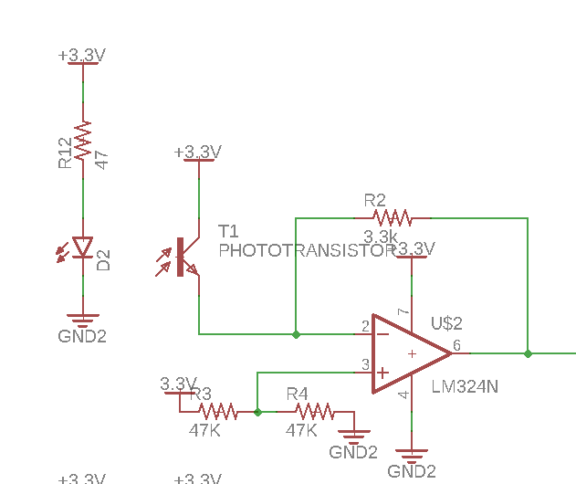

Didn’t yield big enough difference so went for:

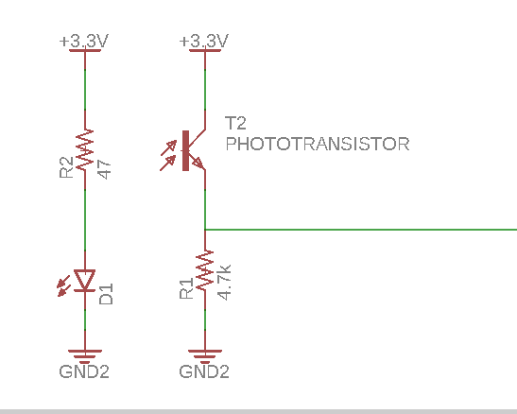

The test code is :

IntervalTimer printTimer;

int line_swiper =0;

void setup() {

Serial.begin(9600);

printTimer.begin(LinePrint, 500000);

}

void loop() {

line_swiper = analogRead(A0);

}

void LinePrint(void){

Serial.println(line_swiper);

return;

}